**“You do, I fix.”**

**-Master Odo**

Kata should always be done with black belt attitude. Let your teachers make the corrections, then adjust the technique.

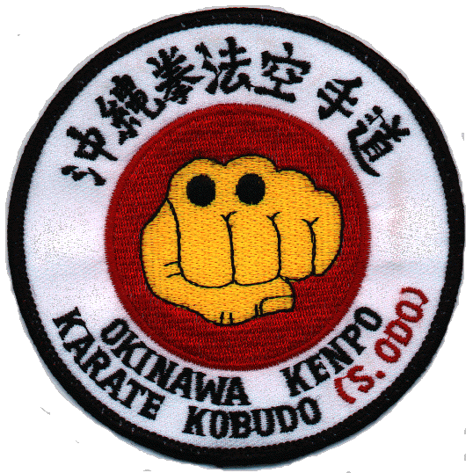

**“I see now that the circumstances of one’s birth are irrelevant. It is what you do with the gift of life that determines what you are“**

**-Hanshi Dargan**

There is no such thing as someone is simply just better than you. Your skill and ability is what you make it, through hard work and dedication. Black belt is a privilege that is to be earned on your own work. Nobody can earn it for you.

**“If you perform kata correctly, you should be sweating.”**

**-Kyoshi DeGori**

Train the body with the fight in mind. If you train lazy, then you will fight lazy. If you train proper technique and with attitude your skill will progress leaps and bounds.

**The 4 A’s of Martial Arts**

1. Attitude
2. Attendance
3. Attire
4. Ability

These principals should be read and spoken in order. These are the keys to success in the martial arts.

**Attitude** is the number one factor in your learning, being willing and excited to learn every class. A positive attitude not only makes you feel better but increases the energy of the entire class.

**Attendance**, you cannot progress if you are not here for class. We should all make an effort to come to class as many times as we can. And we should attempt to do the best that we can in every class.

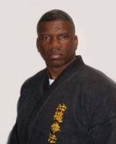**Attire**, you must present yourself in a manner fitting for class, this keeps yourself from being distracted and the rest of the class from being distracted.

**Ability**, this is the last factor that you need to worry about. Your ability will improve by focusing your efforts in attitude, attendance & ability.

**OKINAWA KENPO KARATE KOBUDO**

**Our Family**

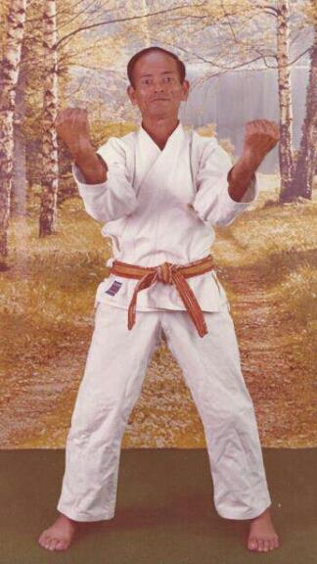

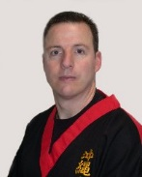

**The Name Okinawa Kenpo**

Our full style name is known as Okinawa Kenpo Karate-Kobudo. Okinawa Kenpo traces its roots back to a style known as Okinawa-Te. Around the early 1950’s Okinawa Kenpo Master Shigeru Nakamura coined the term Okinawa Kenpo. It is Master Odo who incorporated the style Kobudo (weapons) creating the style Okinawa Kenpo Karate Kobudo.

**Let’s break down our style name.**

Okinawa – The Island off the coast of Japan where our style and karate as the world knows it today came from.

Kenpo – Translates to fist law. This is shown on the kanji we wear on our uniforms as black belts which translates to Okinawa Fist Law.

Karate – Translates to empty hand. Referring to seeking peace not conflict. Our student creed states our goal to never be abusive or offensive. The Karate Creed states the following:

**I come to you with only Karate, empty hands, I have no weapons; but should I be forced**

**To defend myself, my principles, or my honor; should it be a matter of life or death, right**

**or wrong, then here are my weapons – “Karate, my empty hands”**

Kobudo – refers to the weapon systems of Okinawa. Master Odo is the reason that we study traditional Okinawa weapon forms today.

So to put it all together we study the Okinawa way of empty hand as well as weapons.

**Your Lineage**

All students should have some knowledge of where they come from. We all know our instructors but do you know who taught your instructor? We should all know Master Seikichi Odo, the founder of our style that we practice today. Master Odo is the one who integrated Kobudo into Karate, creating Okinawa Kenpo Karate Kobudo.

Master Odo was born in 1926 and started his martial arts training at the age of 8. He began his Okinawa-Te training at the age of 13 under Koho Kuba and began Kobudo training at the age of 20 under Shinko Matayoshi.

A fun fact for you: Who taught Master Odo? 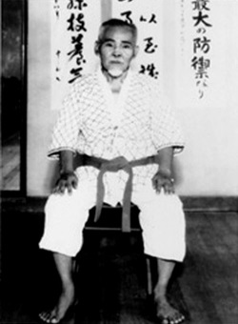

Master Odo had MANY teachers during his time as a student, Shinko Matayoshi, Shigeru Nakamura, Koho Kuba, Seike Toma, Kenko Nakaima; however it was Shigeru Nakamura he called his primary teacher in Karate. Master Odo began his training with Master Nakamura at the age of 23.

So who taught Master Nakamura?

Masters Choma Hanashiro and his teacher

Anko Itotsu. 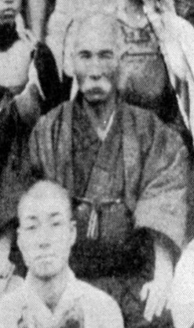 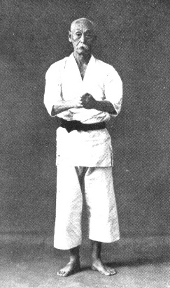

Taught

Anko Itotsu Choma Hanashiro

Itotsu was the teacher of Gichin Funakoshi, a name known worldwide in karate. Master Itotsu was taught by Sokon “Bushi” Matsumura Taught by Kanga Sakugawa, one of the founders and creators of karate.

Master Odo taught Hanshi Dargan who we all know taught Kyoshi Brian DeGori. If it were not for both of these gentlemen the OKKA schools we go to today would not exist.

OKKA began in New Jersey, with its Pitman location in 1995, West Deptford in 2001, Swedesboro in 2003, and Mullica Hill in 2011. Our mission “OKKA believe that Focus, Discipline and Respect are the core beliefs of a foundation for teaching children, teens and adults how to achieve their goals and become the Leaders of their environment and community.” has not changed, only expanded throughout the years.